[**Back to HCI Lab Home Page**](http://iitg.vlab.co.in/?sub=72&brch=170)

**Card Sorting**

Card sorting is a technique used by information architects that is used as  input for defining stucture  of a website or a product. The subject experts or "users", are suppose to create a category tree or [folksonomy](http://en.wikipedia.org/wiki/Folksonomy) from the information provided. Creating [folksonomy](http://en.wikipedia.org/wiki/Folksonomy) helps in designing [information architecture](http://en.wikipedia.org/wiki/Information_architecture), workflows, menu structure or web site navigation paths.

Card sorting helps to build the structure for a website, decide what to put on the home page, and label the home page categories. It also helps to ensure that you organize information on your site in a way that is logical to your website users. It  is  most helpful  while designing a navigation structure for an environment that offers an interesting variety of content and functionality.

**Definition**

Card sorting is a user-centered design method for increasing a system’s findability. The method involves users in grouping information by sorting a series of cards, each labeled with a piece of content or functionality, into groups that make sense to users or participants. Participants in a card sorting session are asked to organize these cards or content in a way that makes sense to them. Participants are also suppose to label these groups.Thus card sorting can provide insight into users’ mental models, illuminating the way that they often tacitly group, sort and label tasks and content within their own heads.

**Methods**

**Open Card Sorting:** Participants are given cards with no pre-established groupings. They are asked to sort cards into groups that they feel are appropriate and then describe each group.

**Closed Card Sorting:** Participants are given cards showing site content with an established initial set of primary groups. Participants are asked to place cards into these pre-established primary groups. Closed card sorting is useful when adding new content to an existing structure, or for gaining additional feedback after an open card sort

**Advantages**

**Simple –** Card sorts are very easy to implenent  by organizers  and  participants  as well.

**Cheap –** Cost of  a  stack of 3×5 index cards, sticky notes, a pen or printing labels, and your time.

**Quick to execute –** Can perform several sorts in short time, that gives significant amount of data.

**Established –** The technique has been used for over 10 years, by many designers.

**Involves users –**Information structure suggested by a card sort involves real users and  hence it should be easier to use.

•

**Card sorting is used when…**

     1. Variety in the items to be organized is large.

     2. Similarities among items make them difficult to divide clearly into categories.

     3. Users may differ significantly in how they view items & groupings of items.

     4. Designer has to explore how people group items, so that he can develop structures that maximize

        the probability of users being able to find items.

Card sorting is a formative techniques and should be used as an input for

       Designing a new site.

   Designing a new area of a site.

   Redesigning a site.

   Research into what users need out of the site.

   A functionality audit/inventory.

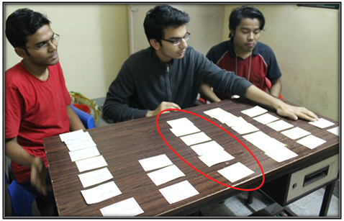

*Card sorting is a great, reliable, inexpensive method for finding patterns in how users would expect to find content or functionality.*

  To proceed  further  click on the **OBJECTIVE** tab on the top or to exit this experiment  click on **HOME**  on the top.

[**Back to HCI Lab Home Page**](http://iitg.vlab.co.in/?sub=72&brch=170)

**After performing this experiment**

1. You will understand  the  card sorting technique used for information architecture design.

2. You  can  actually  perform  online card sorting  for  three  sample  cases and  compare  results  obtained for various user's.

3. You will  be  able  to  apply  card  sorting  method  to any other  design  situation  for  gathering  user's  mental models  helpful in  organizing  the  content  and  navigation  on a webpage.

To proceed  further  click on the **PROCEDURE** tab on the top or to exit this experiment  click on **HOME**  on the top.

[**Back to HCI Lab Home Page**](http://iitg.vlab.co.in/?sub=72&brch=170)

**Demo             :  Step 1 to 4**

**Sorting  Tool :  Step  5, 6, 7**

1. At the beginning you will be introduced to card sorting once again. Press **<next>** to proceed.   
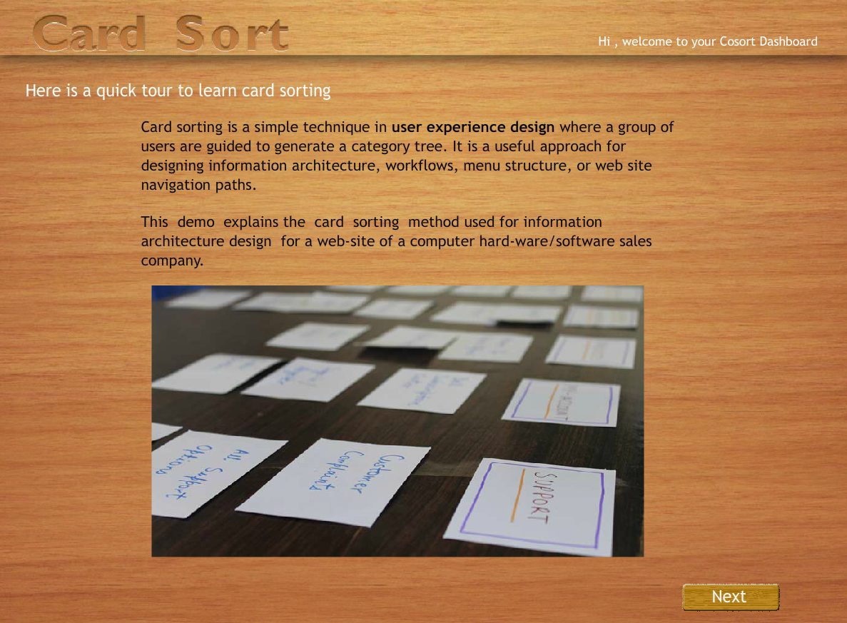

2.  In next screen you will be shown some dummy predefined categories for  grouping the cards.

     Press  **<next>** to proceed  and  **<pevious>**  to  go  back.

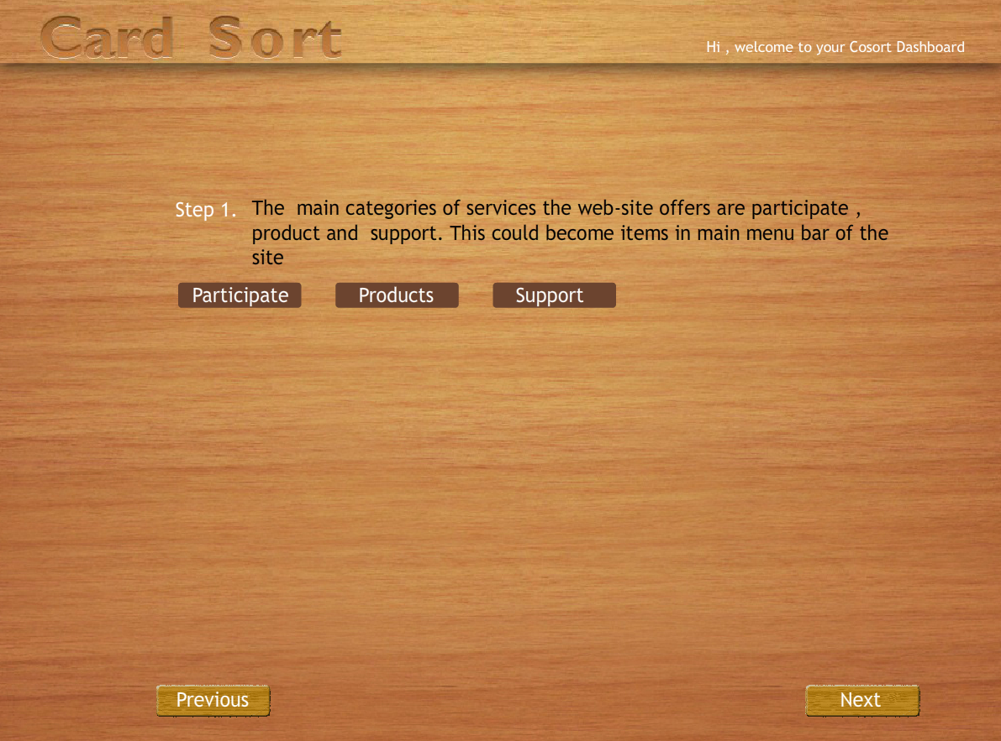

3.  Next  some  dummy cards  will  be  displayed  which  have to be sorted.

     Press  **<next>** to proceed  and  **<pevious>**  to  go  back.

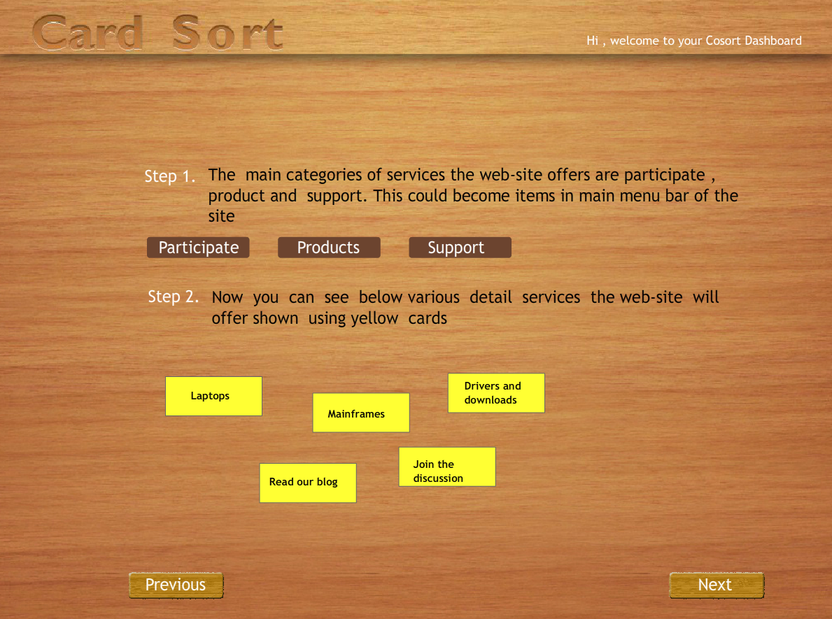

4.  The screen will display the cards sorted as per predefined categories.

     Press  **<next>** to proceed  and  **<pevious>**  to  go  back.

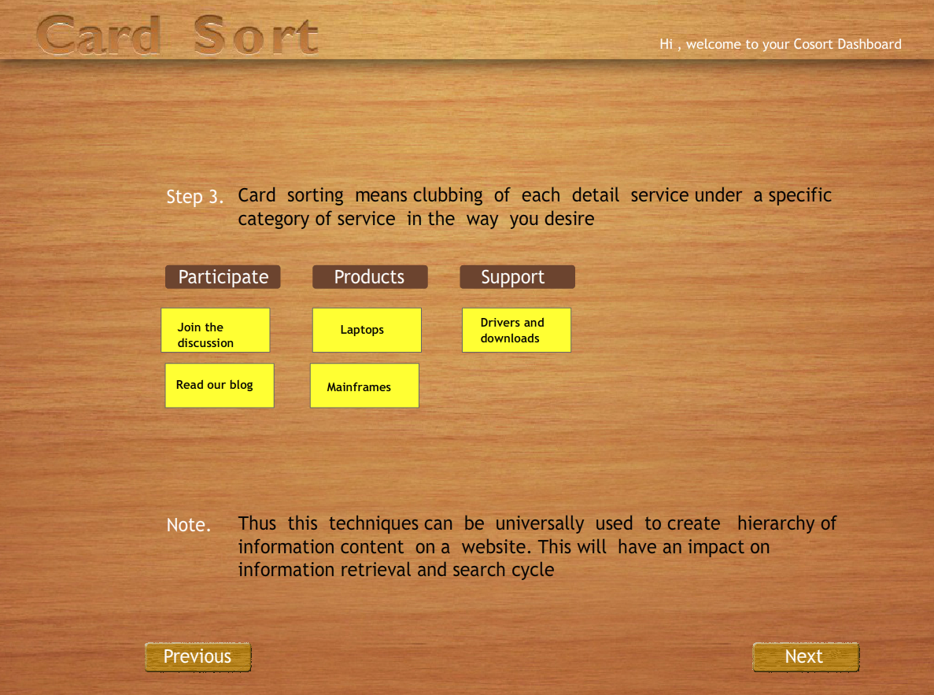

5.  Now  you  will be  asked  to  choose any one from three websites.

     Click  on  any  website  image to  select.

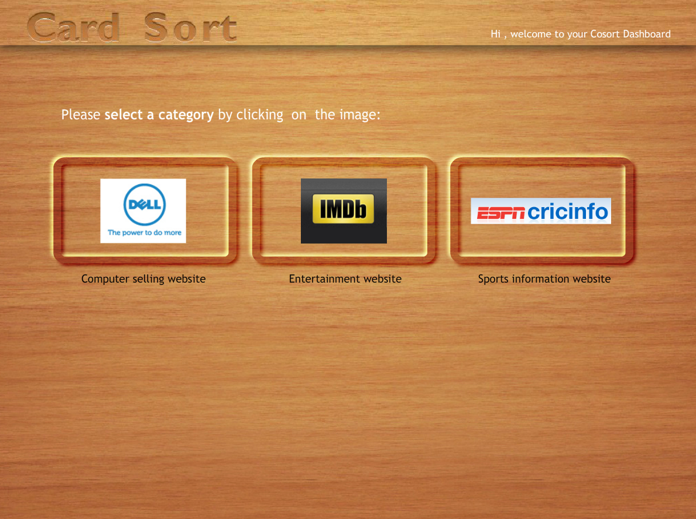

6.  A  set   of  twenty-five  unsorted  cards  with  predefined  categories  will  be  shown.

     Drag  each  card  and  post it  under  category  of  your  choice. You  can  see  your

     progress on  the  progress-bar  below.  You  will  not  be  able  to  move  ahead  unless

     all  cards  are  sorted.  You  can  drag  and   remove  a  card  put  under  some  category

     and  put  it  under different category.

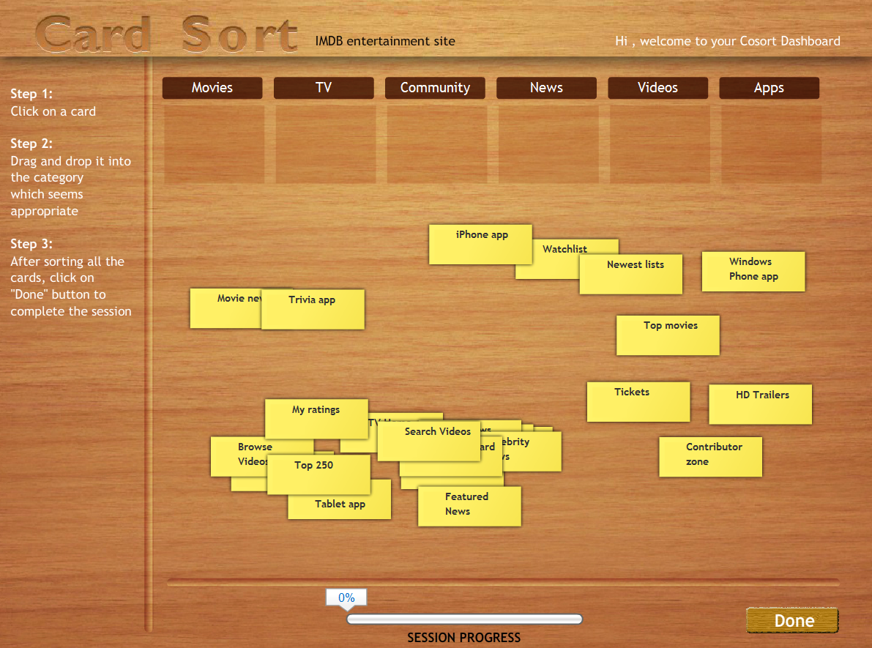

7. Press  **<done>**  button  after  you  sort  all   cards.The  tool  will  display

    a  comparative chart  of  your sorting outcome and  a common  or  ideal

       information architecture  side-by-side.

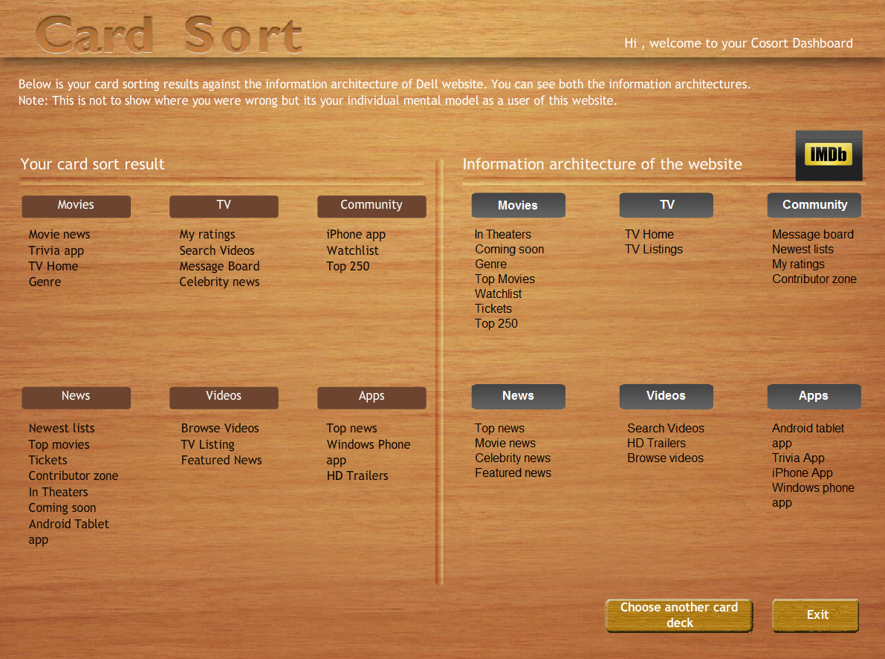

 To proceed  further  click on the **SIMULATOR** tab on the top or to exit this experiment  click on **HOME**  on the top.

[**Back to HCI Lab Home Page**](http://iitg.vlab.co.in/?sub=72&brch=170)

To activate Card Sorting Tool:  [](http://125.20.82.167/uelabs/exp15/card-sort.html)

To proceed  further  click on the **QUIZ** tab on the top or to exit this experiment  click on **HOME**  on the top.

[**Back to HCI Lab Home Page**](http://iitg.vlab.co.in/?sub=72&brch=170)

**Quiz**

1. When should a designer use a card-sorting technique?

2. Can you explain in details the card sorting procedure?

3. What are the drawbacks of the card sorting technique?

4. When to use open card sorting against closed card sorting technique?

5. What are the deliverables of this technique and how are they useful in further design process?

 To proceed  further  click on the **ASSIGNMENT** tab on the top or to exit this experiment  click on **HOME** on the top.

[**Back to HCI Lab Home Page**](http://iitg.vlab.co.in/?sub=72&brch=170)

**Open Card Sorting** ( * refer  procedure below )

Refer to the figure below. You can see some cards that have names of the website sections written on them. Create  such  cards  and  use  them  with  five people for card sorting. These participants are supposed to sort them into groups of their choice and also name these groups.

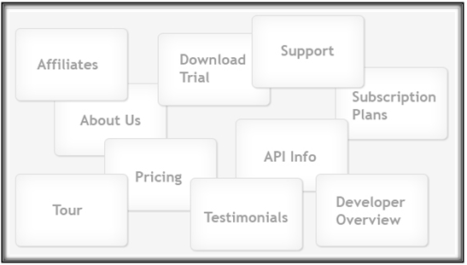

**Please observe following things from the data obtained**

What names do the participants choose for section titles?

What is the average number of categories created by participants?

Were there sub-categories or sub-groups?

Does the content flow logically?

**Closed Card Sorting** ( * refer  procedure below )

Refer to the figure below.  Some cards are  shown  with  names of the website sections written on them. Also  some  categories  are  predefined in blue  color. Create  such  cards  and  use  them  with  five people for card sorting. The participants  are supposed to sort them into the  group  of their choice.

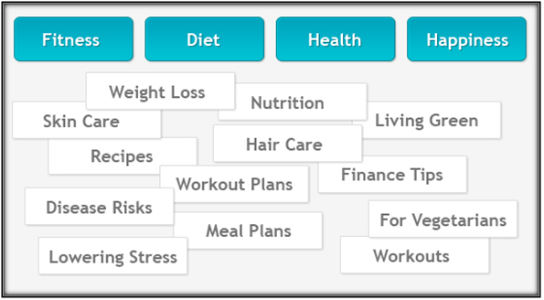

**Please observe following things from the data obtained**

Which cards do the participants put under each category?

Do  you  observe  any  pattern  in  card sorting?

Can you arrive at some solution for information flow design?

**\* Conducting Generic Card Sort**

**Making cards ready**

1.      List the content topics or types of information that you are likely to have on the site or list the most important types of content on your current site.

2.      Write each topic on a separate index card. Limit yourself to 100 cards or less. (About 50 is a good number.)

3.   Have blank cards available for participants to add topics and to name the groups they make when they sort the cards. Consider using a different colored card for having participants name the groups.

4.      Plan about one hour for each session - longer if you have many cards.

5.    Arrange for a space where the participant has enough room to spread the cards out on a table. A conference room works well.

6.      Plan to have someone take notes as the participant works and thinks aloud.

**Sorting Session**

1.      Show the participant the set of cards and explain that you are asking for help to find what categories of information should be on the site's home page and what those categories should be called.

2.      Ask the participant to talk out loud while working. You want to understand the participant's thoughts and rationale.

3.    Let the participant add cards - for example, to indicate lateral hyperlinks or additional topics. Let the participant put cards aside to indicate topics the participant would not want on the site. Minimize interruptions but encourage the participant to think aloud.

4.      Give the participant a stack of different colored cards and ask them to use the colored card to name each group.

**Analyzing Data**

1.      Write down the names that participant gave to each grouping and the numbers of the cards the participant included under that name.

2.   Create a computer file for each session. Working from your original list of topics, move topics around to recreate each participant's groupings and enter that participant's name for the groupings.

3.      Use your notes and recordings of the participants' names and card numbers under each person's name to find commonalities from different sessions.

4.     For a more detailed analysis, consider using an Excel spreadsheet to show the relationship between the cards or use one of the available software programs to analyze your data.

( Reference : http://www.usability.gov/methods/design_site/cardsort.html )

 To proceed  further  click on the **REFERENCE** tab on the top or to exit this experiment  click on **HOME** on the top.

[**Back to HCI Lab Home Page**](http://iitg.vlab.co.in/?sub=72&brch=170)

**Articles  and  Urls**(as on 23/4/2012)

1. Hiroshi Ishii, Minoru Kobayashi, Kazuho Arita. Iterative design of seamless

    collaboration media. Communications of the ACM, August 1994/Vol. 37, No.8

2. Jakob Nielsen. "Card Sorting to Discover the Users' Model of the Information

    Space".Useit. 1995.[online]  
    http://www.useit.com/papers/sun/cardsort.html [Accessed on 10 Oct 2011]

3. Jakob Nielsen. "Card Sorting: How Many Users to Test".Useit. 2004. [online]  
    http://www.useit.com/alertbox/20040719.html [Accessed 10 Oct 2011]

4. Card Sorting- Introduction[Online].

    Available from http://www.syntagm.co.uk/design/cardsortintro.shtml

    [accessed 25 August 2011]

5. Neil Turner. UX for the masses. [online]  
    http://www.uxforthemasses.com/online-card-sorting/ [Accessed 10 Oct, 2011.]

6. http://www.usability.gov/methods/design_site/cardsort.html

7. http://www.boxesandarrows.com/view/card_sorting_a_definitive_guide

To give feedback  for this experiment click on the **FEEDBACK** tab on the top or to exit this experiment click on **HOME**  on the top.